

**Experiment No.: 6 Title: Usability Testing**

**Batch:B1 Roll No.:16010421119 Experiment No.:6 Aim:** To perform usability testing using any open source tool.

**Resources needed:** Internet, Chrome Browser

**Theory:**

Usability testing also known as User Experience (UX) testing, is a testing method for measuring how easy and user-friendly a software application is. A small set of target end-users, use software application to expose usability defects. Usability testing mainly focuses on user's ease of using application, flexibility of application to handle controls and ability of application to meet its objectives. This testing is recommended during the initial design phase of SDLC, which gives more visibility on the expectations of the users.

Users are asked to complete tasks, typically while they are being observed by a researcher, to see where they encounter problems and experience confusion. If more people encounter similar problems, recommendations will be made to overcome these usability issues.

”Usability engineering” is the process of identifying users’ needs to ensure a product can achieve specific goals effectively and efficiently, which results in overall satisfaction and success. To mitigate user issues and ensure your product is working for its intended audience, you need to venture into the world of usability engineering.

Usability is a combination of many factors and theories, but all can be targeted to achieve the goals below:

* Intuitive Design and/or user interface
* Ease of learning
* Efficiency of use
* Memorability
* Error prevention
* User Satisfaction

It is important for any web designer to design functional sites that can easily generate interest and online traffic among the internet users. The **user interface design** of your site plays a vital role in bringing high volume web traffic to it. Therefore, web designers should give due importance to the **user interface** of the site which is being designed by them. In the present era, there is an explosive growth in the e-commerce with billions of dollars worth of sales taking place each year. Today, thousands of businesses are completely dependent on the internet for their success.

Internet has emerged as a one-stop source of entertainment, information, social interaction and commerce. For success in any online business, a user friendly website is a must as it will provide enhanced user experience to the online visitors. Any site that is too complex and difficult will definitely push away online traffic. The use of effective and simple user interface design will be of immense help in achieving the objectives of a website. A good user interface not only increases the site usability but also leads to the smooth completion of any task at hand thereby making everything enjoyable and flexible as per the requirements of users.

Following are the tools which are useful in usability testing:

* Lighthouse
* Website Grader
* Google PageSpeed Tools
* GTmetrix

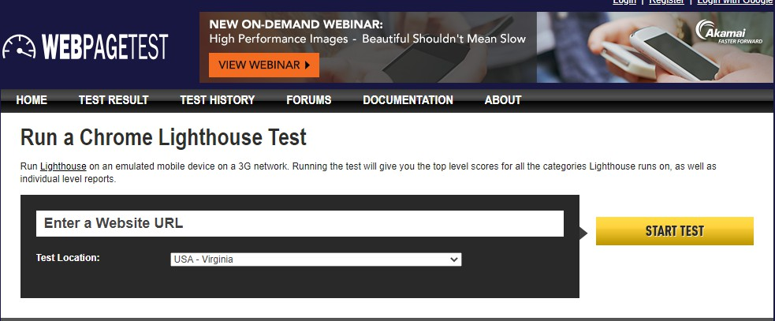



Webpagetest: Lighthouse

**Procedure:**

1.

2.

3.

4.

Explore any one tool for usability testing.

Perform usability testing of any website and generate the report for the same. Analyze and summarize report for quality and performance of web pages.

Suggest improvements based on your analysis.\

this is the tool we are using for usability testing- <https://pagespeed.web.dev/>



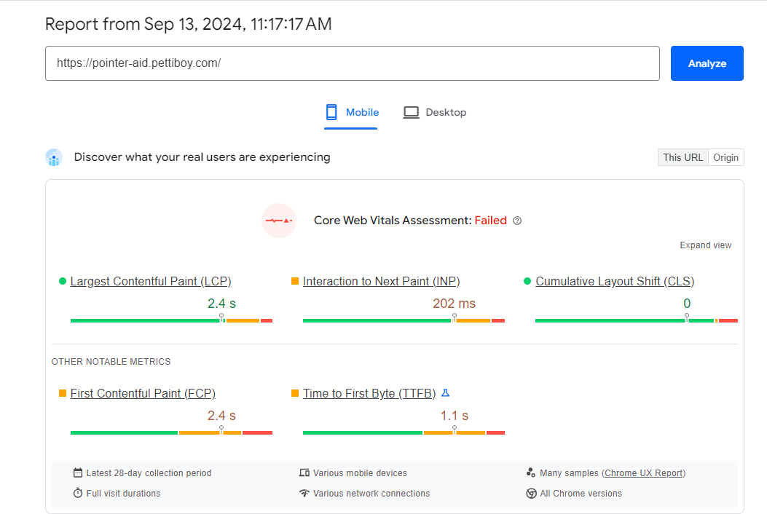

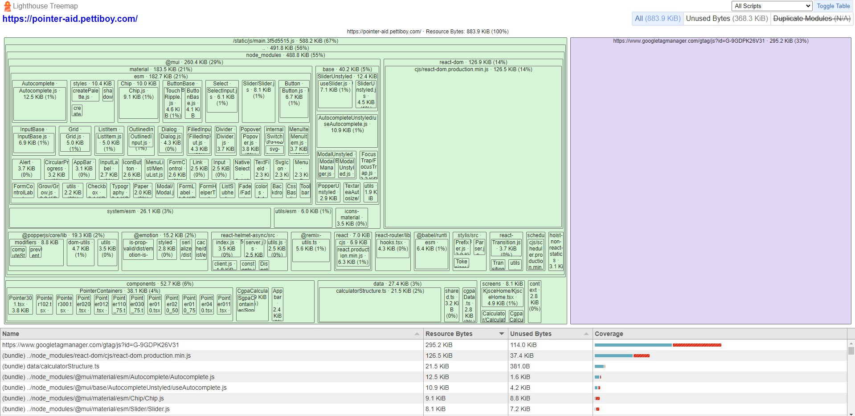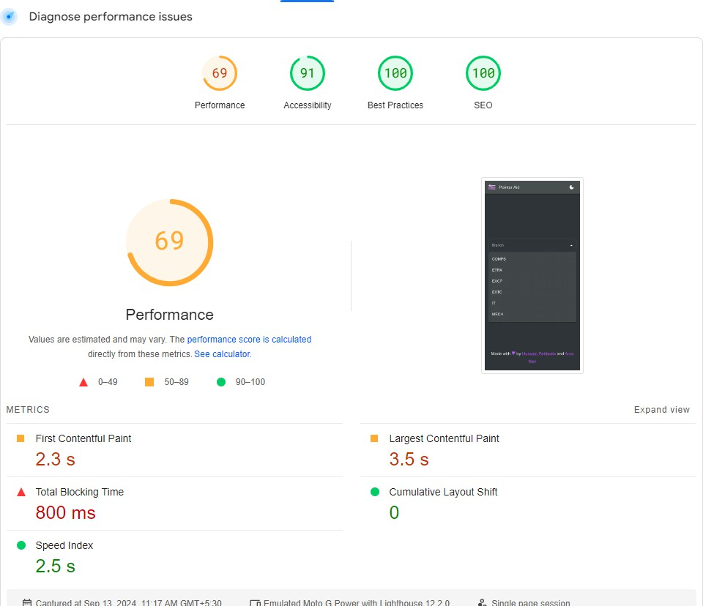

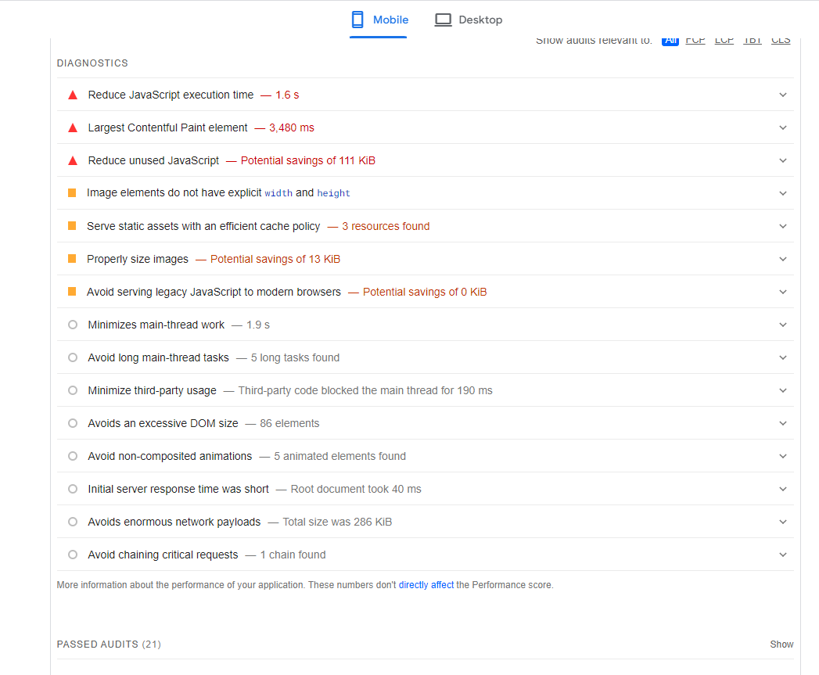

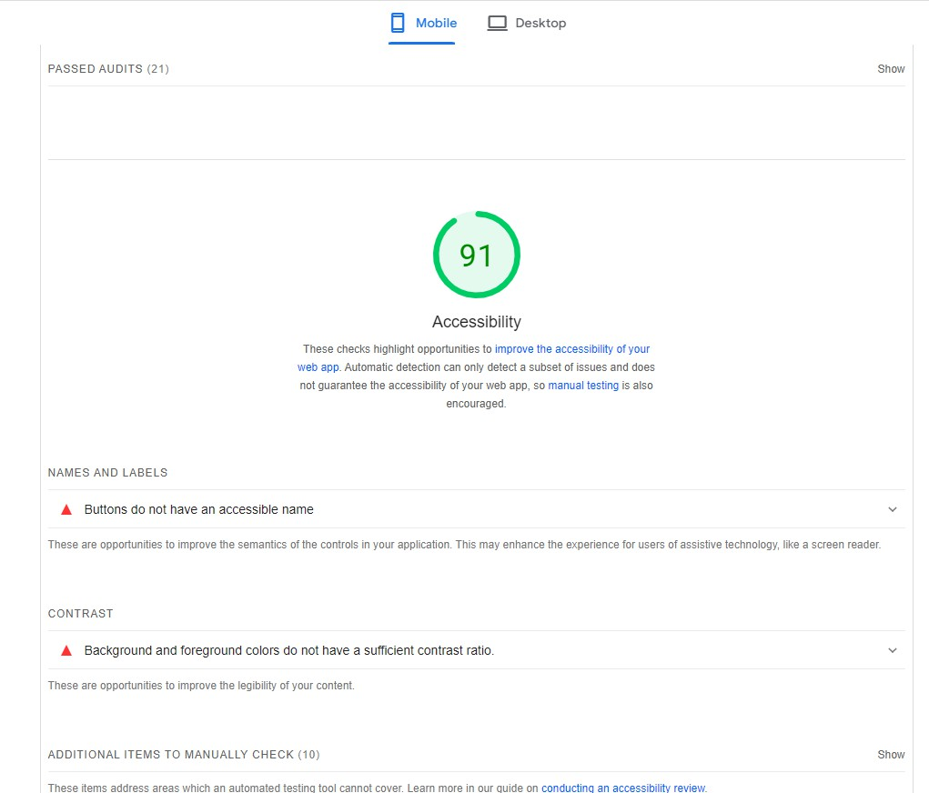

Desktop

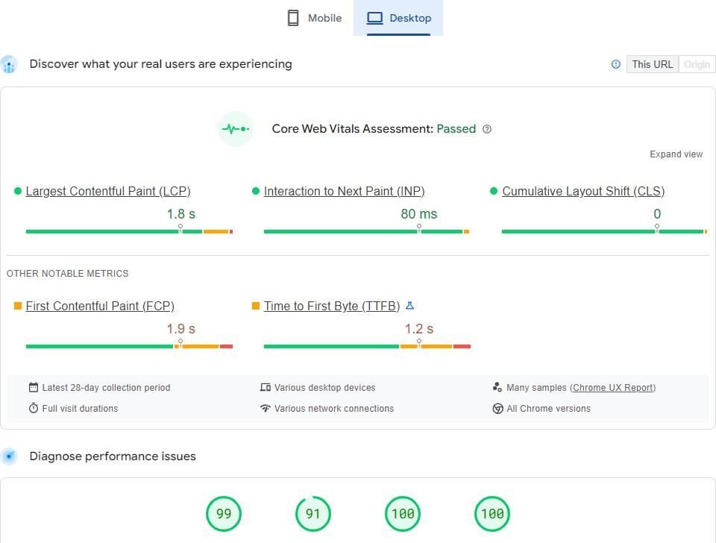

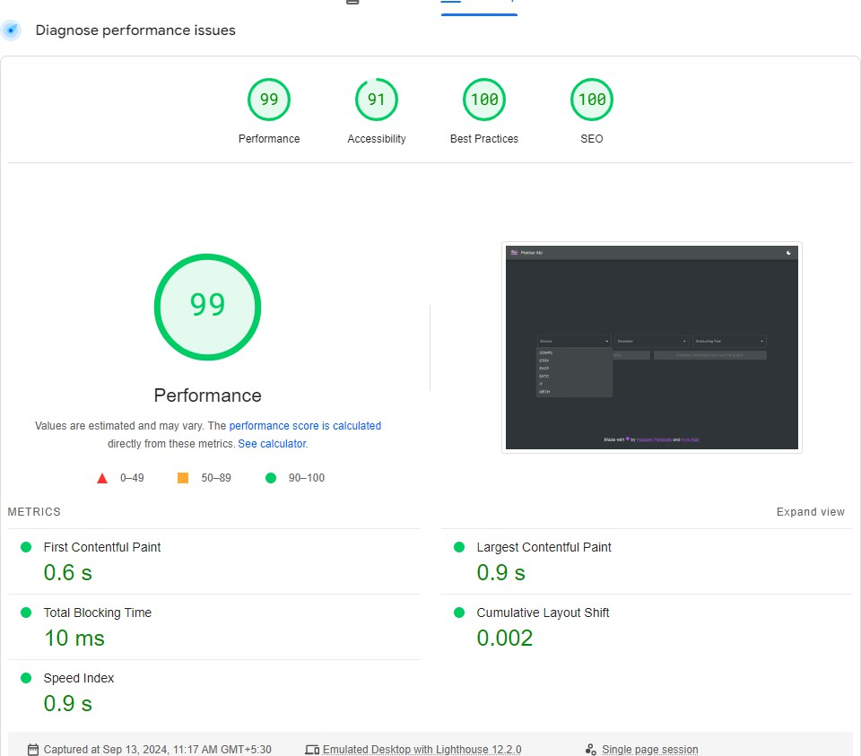

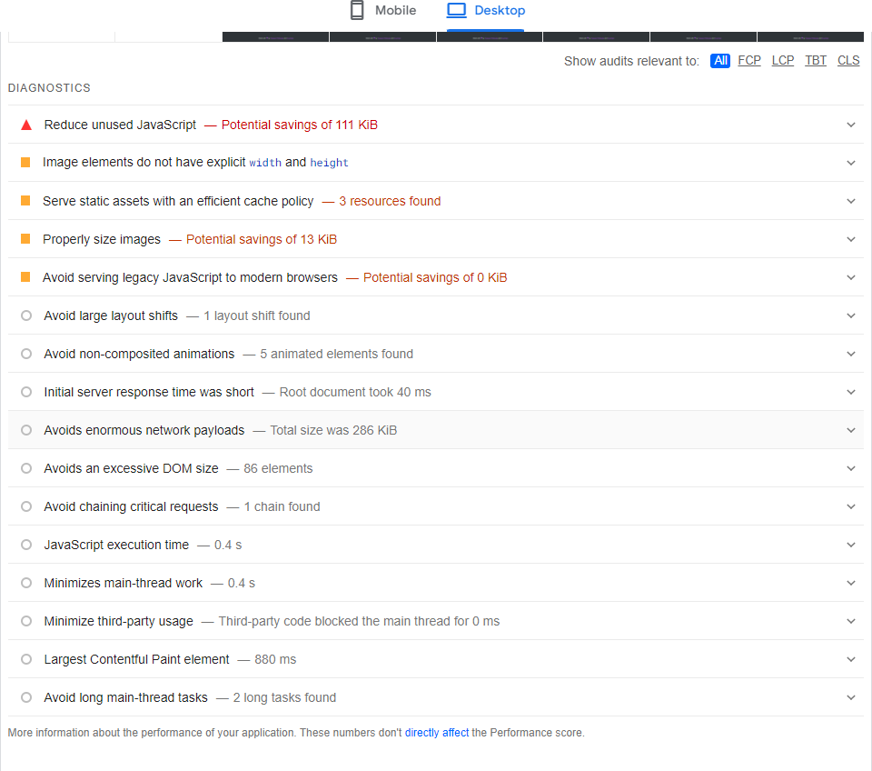

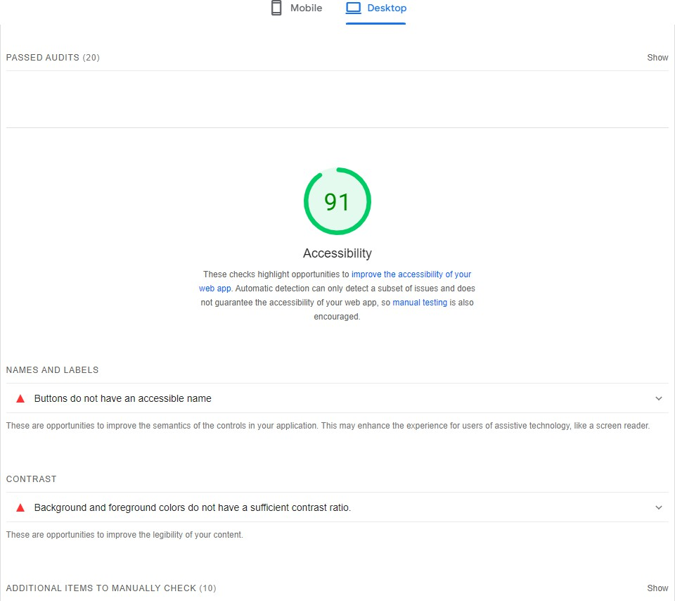

These reports are generated using lighthouse

To improve accessibility we should take in following points

1. Buttons need to have an accessible name
2. The contrast ratio between background and the text should be increased to make it much more easier for the users to read

**Questions:**

1. Describe usability and accessibility testing. Explain any five test cases/scenarios for testing usability and accessibility of a web application.
   * Keyboard Navigation (Accessibility): Verify that all interactive elements can be accessed and operated using only the keyboard with visible focus indicators.
   * Screen Reader Compatibility (Accessibility): Ensure that a screen reader correctly reads and navigates through all content and interactive elements.
   * Form Validation and Error Messages (Usability & Accessibility): Check that error messages are clear, specific, and accessible, guiding users to correct their input.
   * Color Contrast and Text Readability (Accessibility): Confirm that text and background color combinations meet contrast standards for readability.
   * Responsive Design and Mobile Usability (Usability & Accessibility): Validate that the application adapts to various devices and screen sizes, with appropriately sized touch targets.
2. What are the benefits of usability testing for website owners? Usability testing offers several key benefits for website owners:
   * Improved User Satisfaction: Identifying and addressing usability issues leads to a more intuitive and pleasant user experience, increasing overall satisfaction.
   * Increased Conversion Rates: A user-friendly website helps streamline processes (e.g., sign-ups, purchases), which can boost conversion rates and drive more business.
   * Reduced User Errors: By uncovering and fixing areas where users struggle, usability testing minimizes errors and enhances the site's effectiveness.
   * Enhanced User Retention: A website that is easy to use and navigate encourages users to return, fostering loyalty and long-term engagement.
   * Cost Savings: Identifying usability issues early in the development process can reduce the need for costly redesigns and fixes after launch.

**Outcomes:**

CO3 Apply recent automation tools for testing software.

**Conclusion: (Conclusion to be based on outcomes) Did usability testing on my own website and found out the weak links**

**Grade: AA / AB / BB / BC / CC / CD /DD Signature of faculty in-charge with date**

**References:**

**Books/ Journals/ Websites:**

1. https://developers.google.com/web/tools/lighthouse/
2. https://developers.google.com/speed/pagespeed/insights/
3. [https://www.webpagetest.org/lighthouse](http://www.webpagetest.org/lighthouse)
4. [https://www.guru99.com/usability-testing-tutorial.html](http://www.guru99.com/usability-testing-tutorial.html)
5. https://gtmetrix.com/